

***DELL FSD – Sporty Shoes Project***

***By***

***Prasanth Chandrasekar***

***TABLE OF CONTENTS***

|  |  |  |
| --- | --- | --- |
| **S.No** | **Content** | **Page Number** |
| **1** | **Problem Statement** | **3** |
| **2** | **Sprints and the User Stories** | **3** |
| **3** | **Jira User Story** | **5** |
| **4** | **Jira Sprint** | **5** |
| **5** | **Tools used in the project** | **6** |
| **6** | **Hierarchy of Codes** | **6** |
| **7** | **Exception Handling** | **7** |
| **8** | **Entity and Tables** | **7** |
| **9** | **Tables Created in Database** | **7** |
| **10** | **Screenshots showing completion of Project requirement** | **8** |
| **11** | **Git Screenshots** | **11** |
| **12** | **GitHub Screenshots** | **11** |
| **13** | **GitHub Repository Link for source Code and other Project related Files** | **12** |

***Problem Statement:***

Sporty Shoes is a company that manufactures and sells sports shoes. They have a walk-in store, and now, they wish to launch their ecommerce portal sportyshoes.com.

You’re asked to develop a prototype of the application. It will be then presented to the relevant stakeholders for budget approval. Your manager has set up a meeting where you’re asked to do the following:

● Presenting the specification document which has the product’s capabilities, appearance, and user interactions  
● Setting up Git and GitHub account to store and track your enhancements of the prototype   
● Explaining the Java concepts used in the project   
● Discussing the generic features of the product:  
● There will be an admin to manage the website. An administrator login will be required to access the admin page.

**The admin should be able to change his password if he wants, he should be able to:**

● Manage the products in the store including categorizing them  
● Browse the list of users who have signed up and be able to search users  
● See purchase reports filtered by date and category

***Sprints and the User Stories:***

***Sprint-1: (One week)***

• ***User Story-1 :***  As an Administrator, I want to have an option to create Users, so that i can set up a master list of Users

• ***User Story-2 :***  As an Administrator, I want to have an option to create Products, so that i can set up a master list of Products

• ***User Story-3 :***  As an Administrator, I want to have an option to view Users, so that i can view a User by Id and also a list of Users.

• ***User Story-4 :***  As an Administrator, I want to have an option to view Products, so that i can view a Product by Id

• ***User Story-5 :***  As an Administrator, I want to have an option to view Products, so that i can view a list of Products.

• ***User Story-6 :*** As an Administrator, I want to have an option to view Users, so that i can view a User by Id..

• ***User Story-7 :*** As an Administrator, I want to have an option to view Users, so that i can view a list of Users.

• ***User Story-8 :*** As an Administrator, I want to have an option to view Products, so that i can view a Product by Category.

• ***User Story-9 :*** As an Administrator, I want to have an option to update Users, so that i can modify a User by Id.

• ***User Story-10 :***  As an Administrator, I want to have an option to update Products, so that i can modify a Product by Id.

***Sprint-2:(one week)***

• ***User Story-1 :*** As an Administrator, I want to have an option to delete Users, so that i can remove Users whenever they are not required.

• ***User Story-2 :*** As an Administrator, I want to have an option to delete Products, so that i can remove Products whenever they are not required.

• ***User Story-3 :*** As an Administrator, I want to have an option to map Products to Users via purchase, so that i can map Products to Users whenever the User purchases Products.

• ***User Story-4 :*** As an Administrator, I want to have an option to reset or change my password, so that i can change or update password whenever required.

• ***User Story-5 :*** As an Administrator, I want to have an option to view purchase report by Date, so that i can see the purchase reports for analysis.

• ***User Story-6 :*** As an Administrator, I want to have an option to view purchase report by Category, so that i can see the purchase reports for analysis by Category.

***Jira User Story – Agile Scrum :***

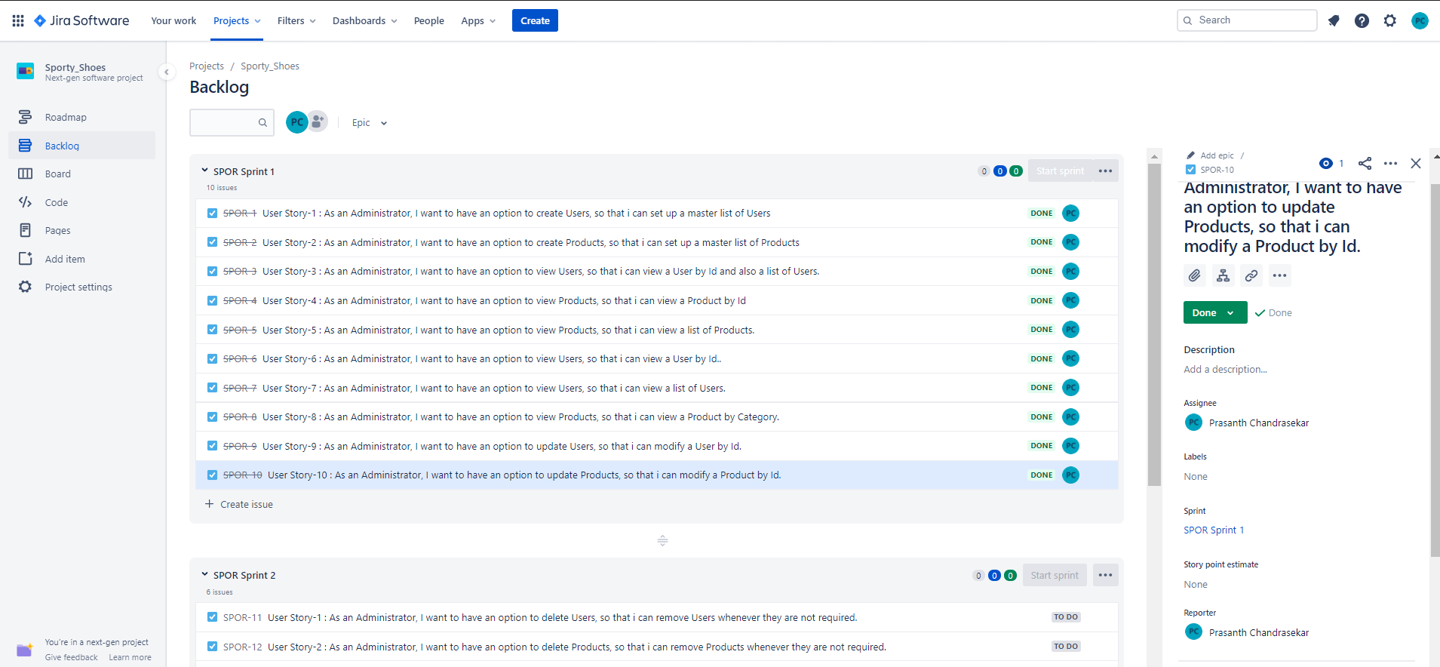

***Jira Sprint– Agile Scrum :***

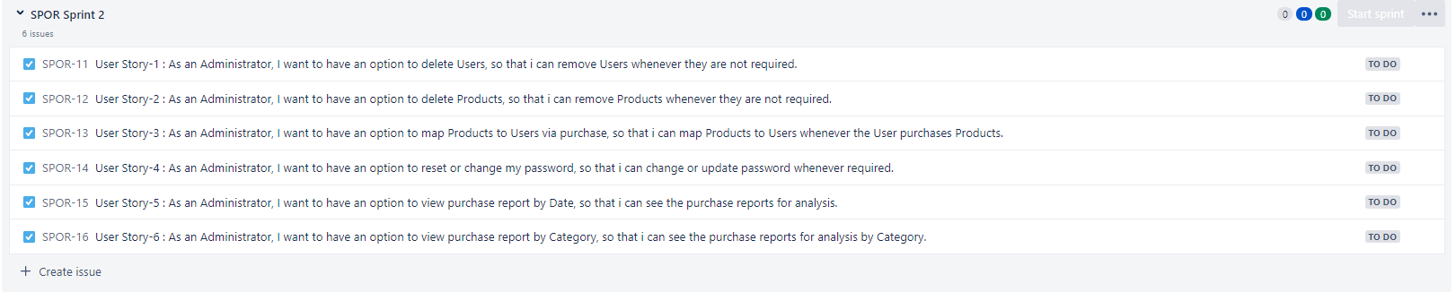

***Tools used in the Project:***

|  |  |
| --- | --- |
| ***Programming Language and related*** | ***Java, JavaScript, TypeScript, Angular, SpringBoot, Angular, TypeScript, html, css, bootstrap*** |
| ***IDE*** | ***Eclipse, Microsoft Visual Code*** |
| ***Database*** | ***H2 – persistent DB*** |
| ***Version Control System*** | ***Git & GitHub*** |
| ***Software Development Methodology*** | ***Agile - Scrum - Jira*** |

***Hierarchy of codes developed:***

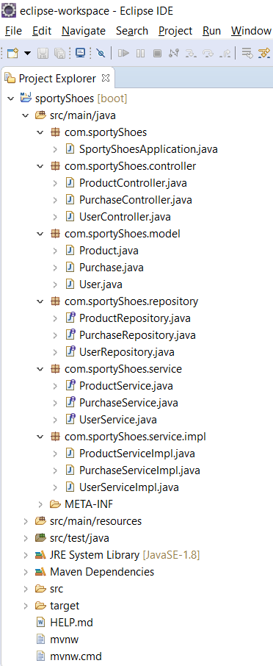 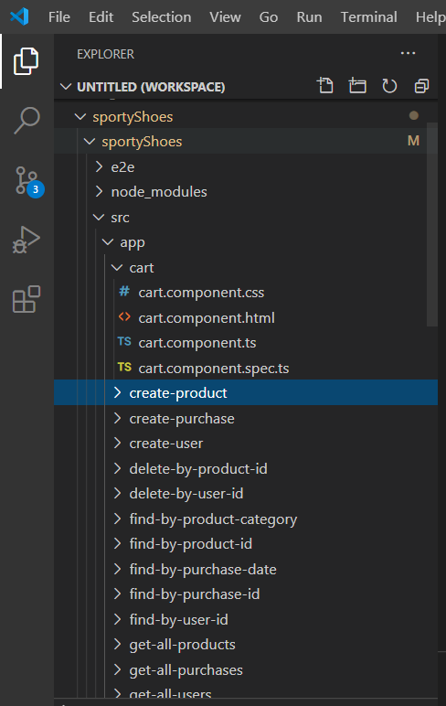 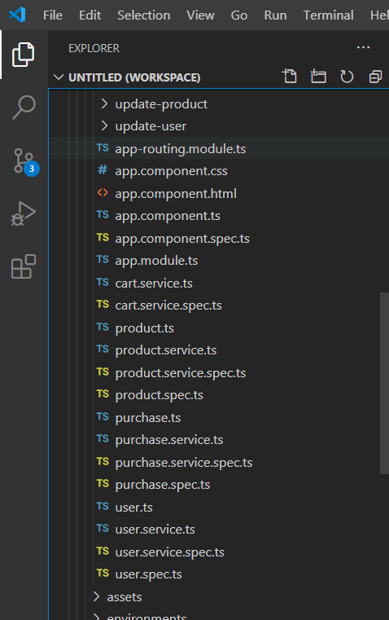

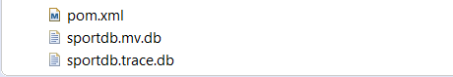

***Exception Handling:***

Some of the exceptions and errors are handled, so that the application won’t close, exit or throw an exception.

***Entity and Tables:***

1. User
2. Product
3. Purchase
4. Cart

***Tables created in Database:***

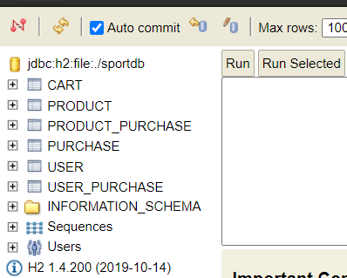

***Screenshots taken while executing project requirements and their verification:***

***Product Home Page***

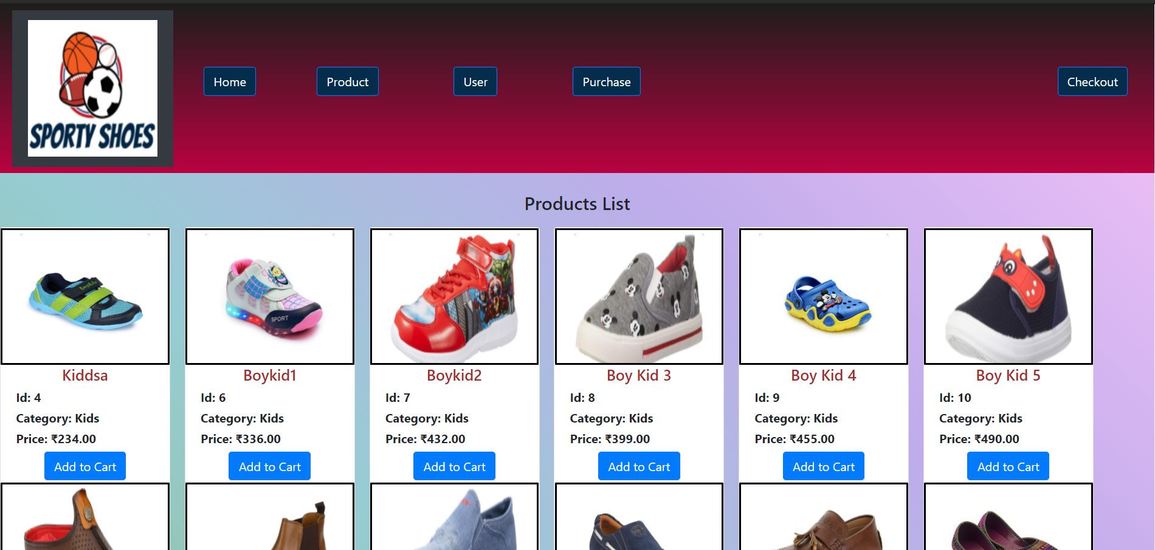

***Pop-up upon clicking “Add to Cart” for each products***

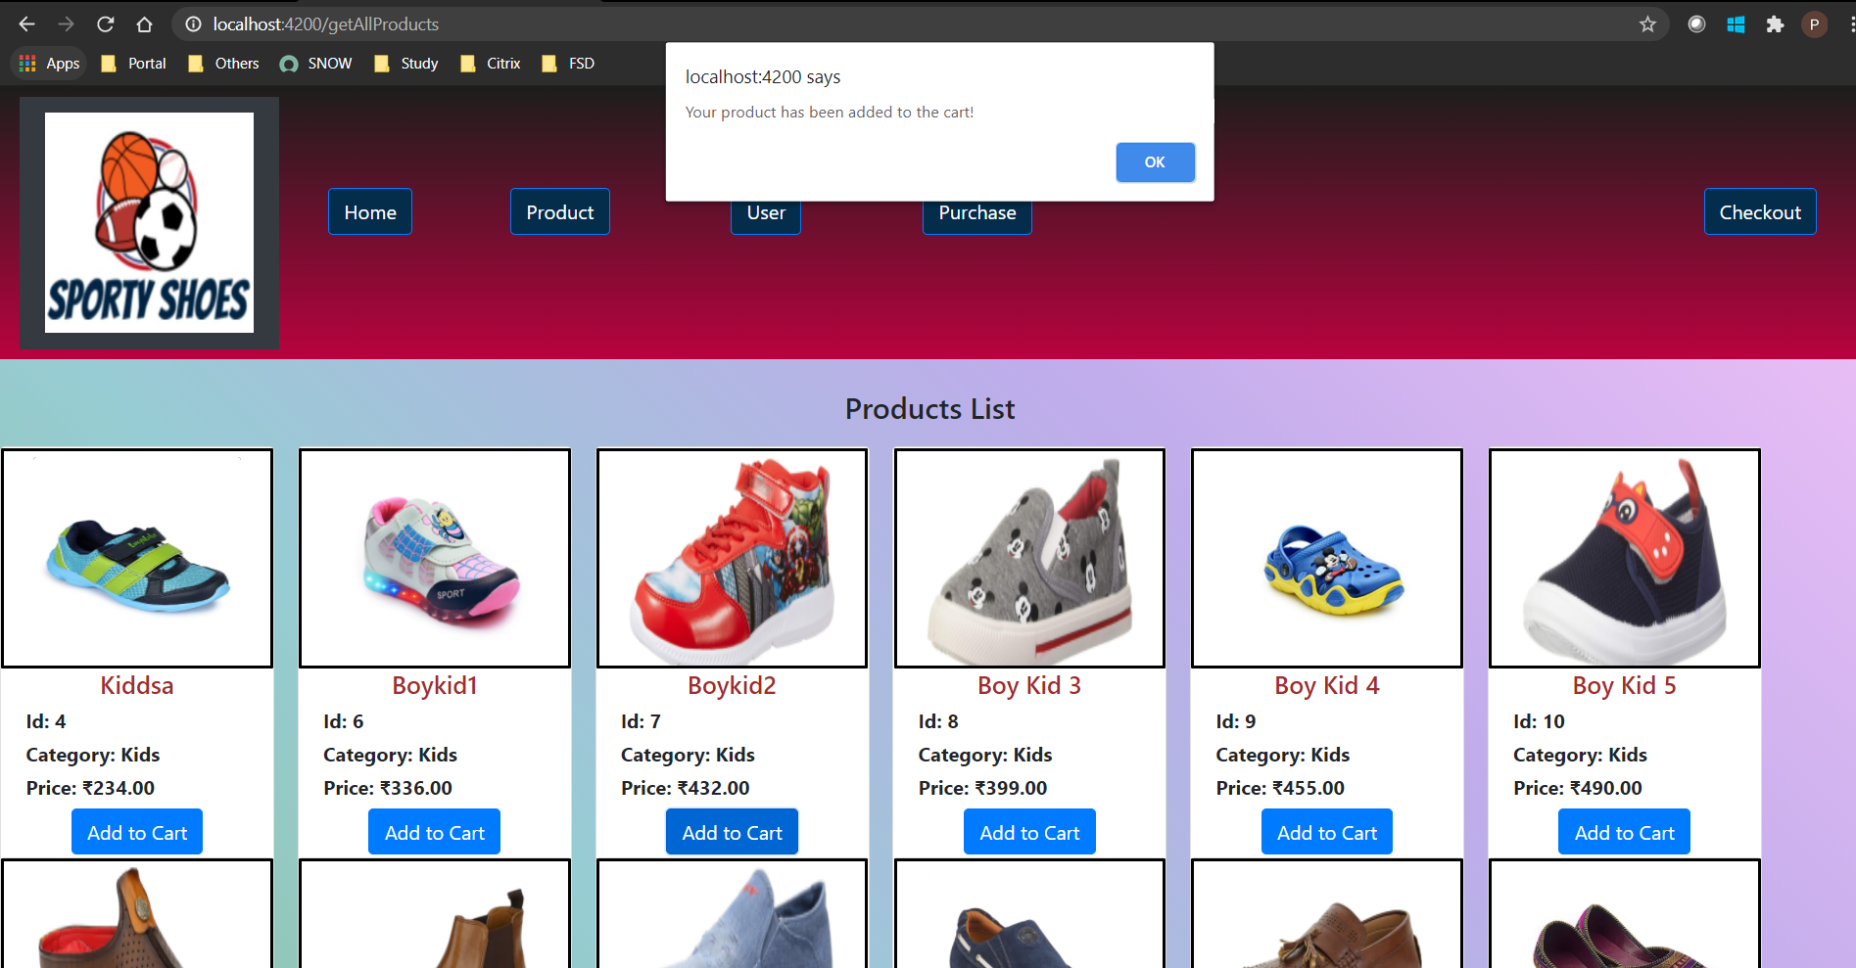

***Drop-Down with highlight on Hover:***

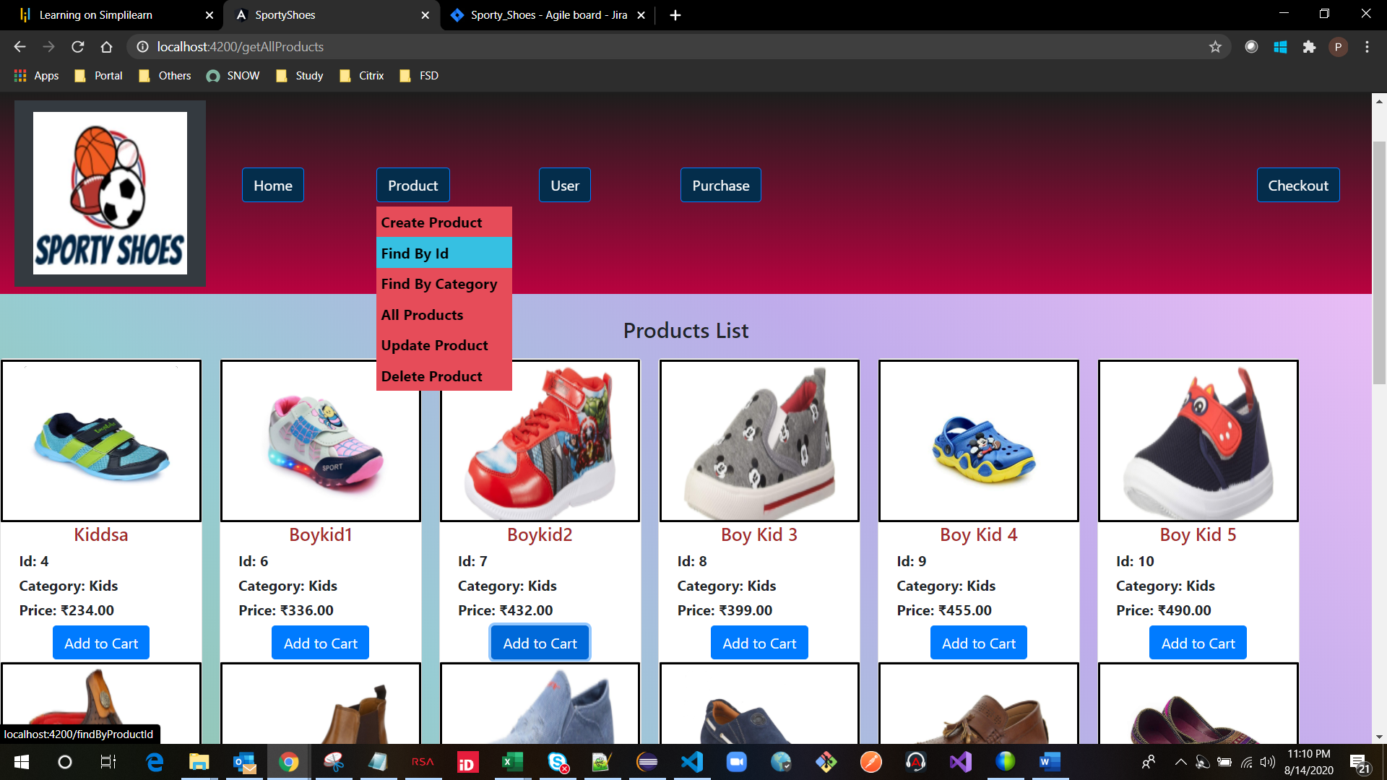

***Option to create/Read/Update/Delete the User and Products:***

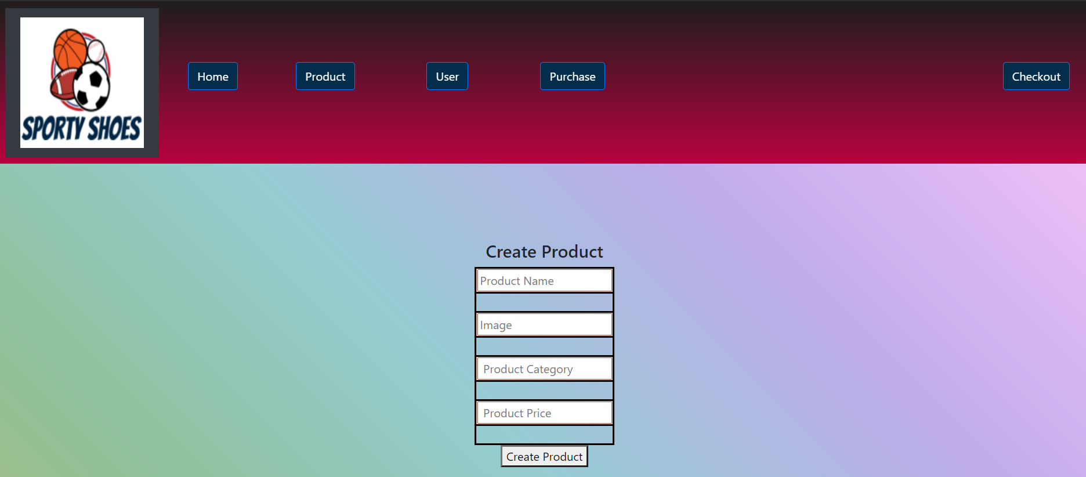

***Purchase Report:***

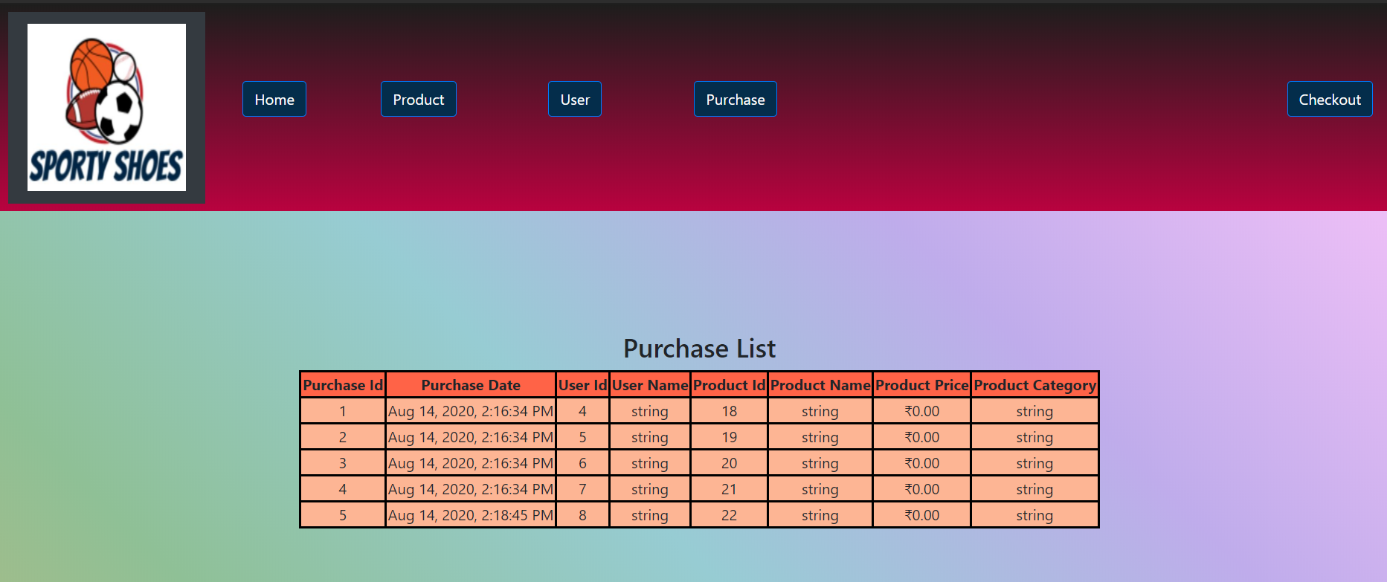

***Checkout Button on clicking shows the Cart contents and an option to Buy:***

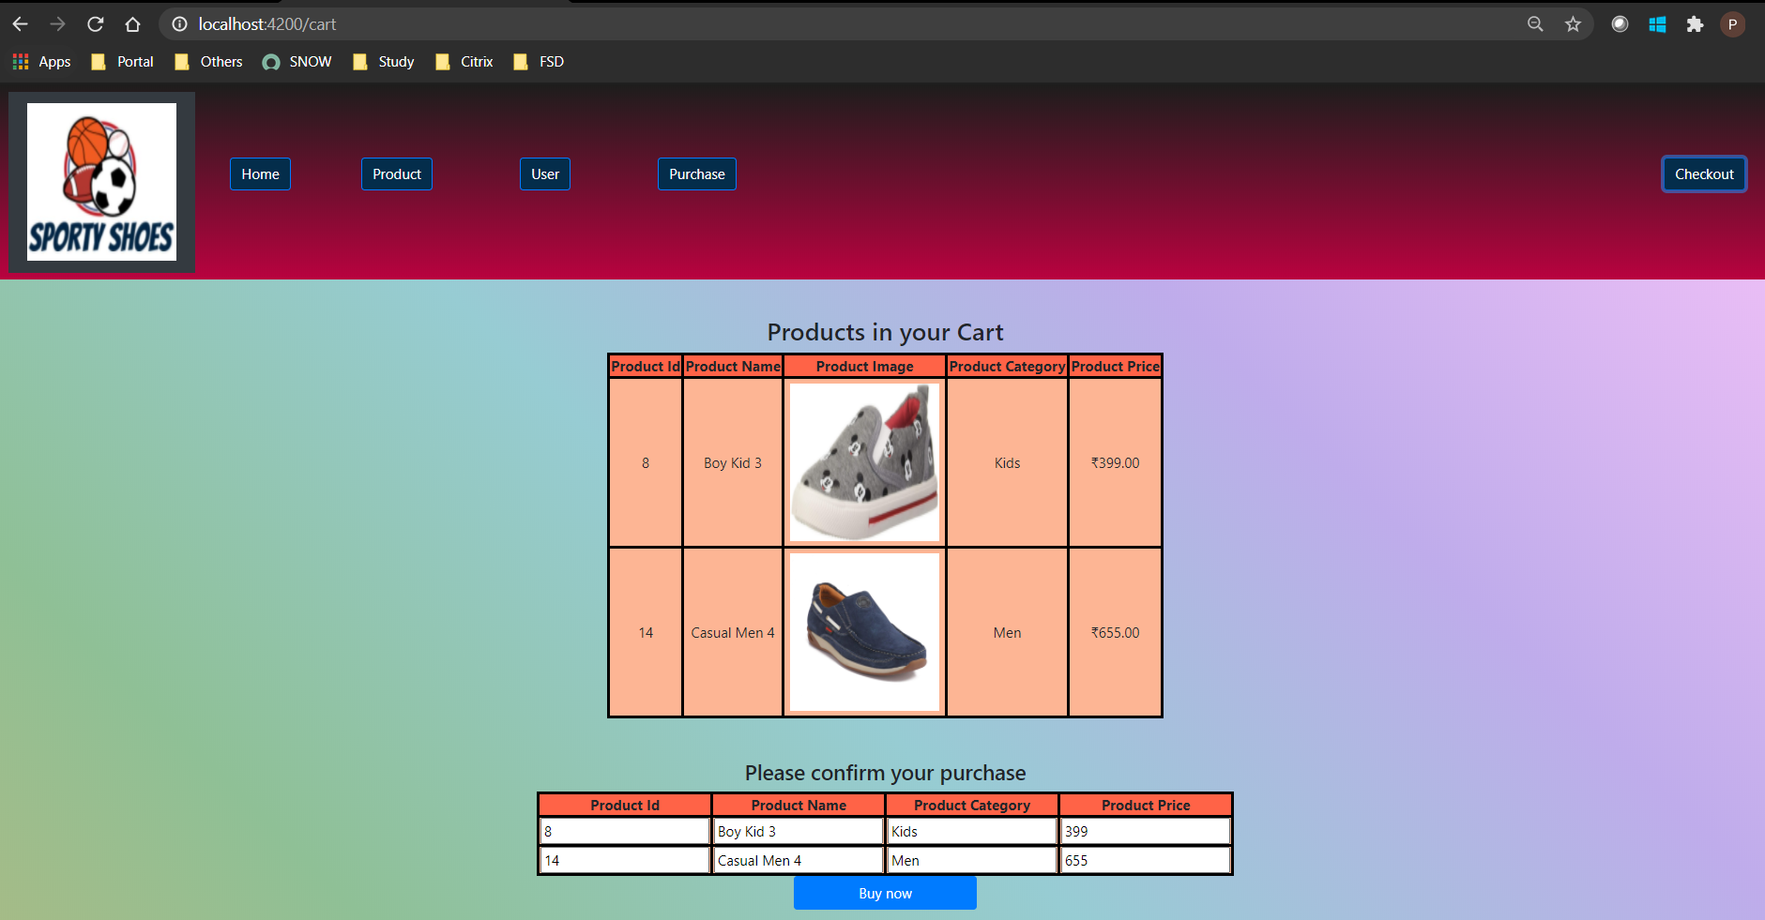

***Git Screenshots:***

***Front End related Codes tracked by Git and uploaded to GitHub:***

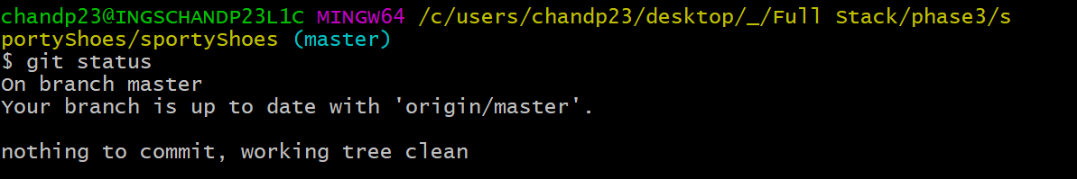

***Back End related Codes tracked by Git and uploaded to GitHub:***

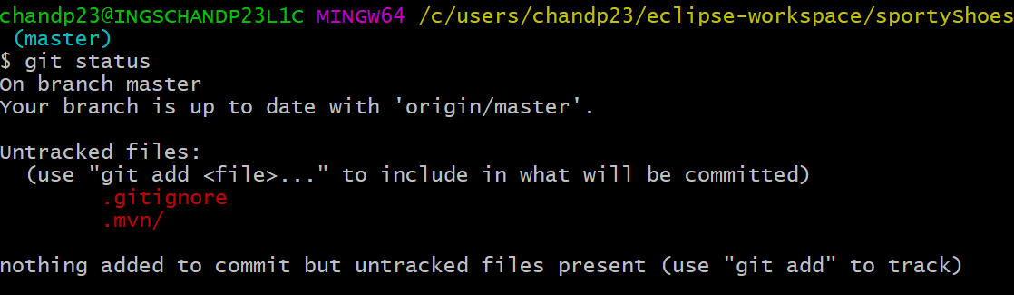

***GitHub Screenshot:***

***Front End related Codes tracked by Git and uploaded to GitHub:***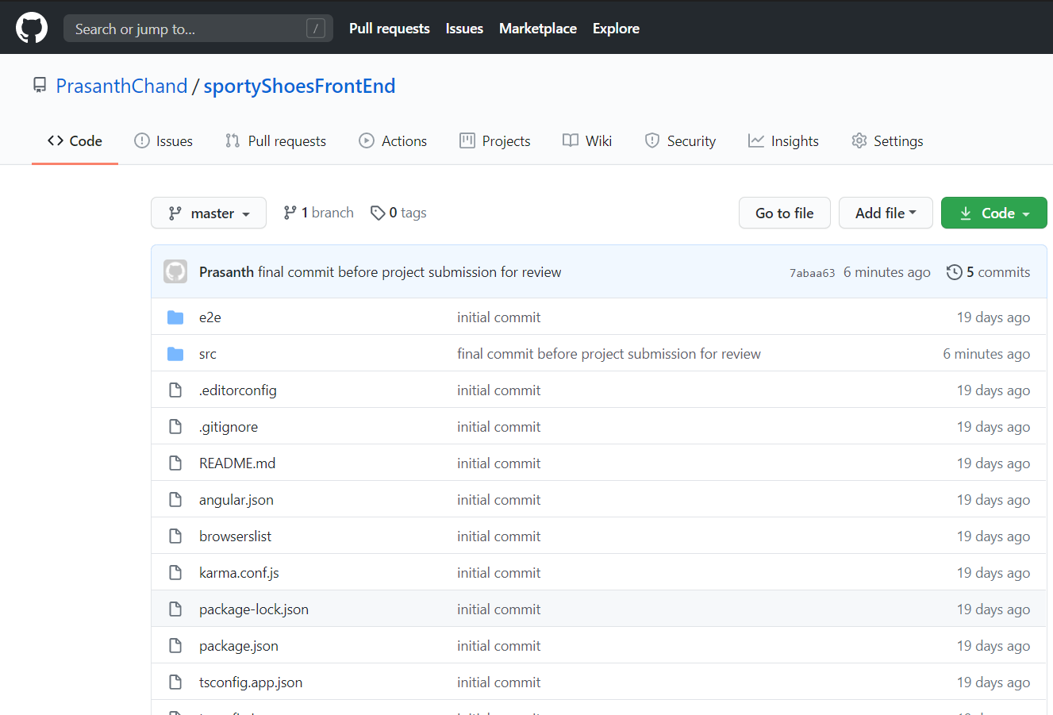

***Back End related Codes tracked by Git and uploaded to GitHub:***

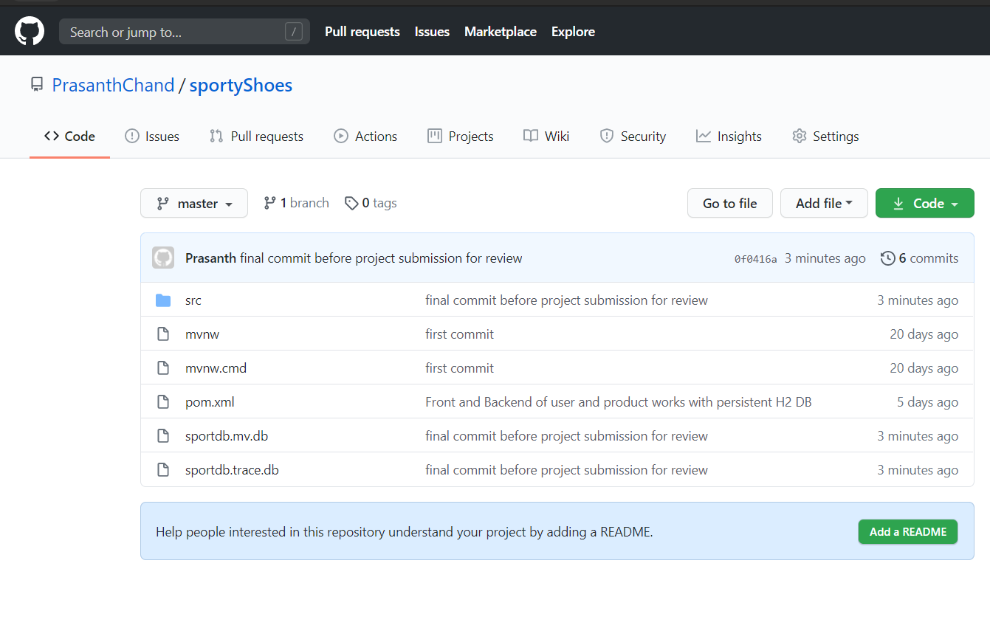

***GitHub Repository:***

***All the project related files are uploaded to the below GitHub repository.***

***Note: The data in the database might be different from the screenshots, as few data were modified for testing purpose after taking screenshot. This project specification document is uploaded to below GitHub Repository in both .doc and .pdf extensions.***

**Front End related codes :** <https://github.com/PrasanthChand/sportyShoes>

**Back End related codes :** <https://github.com/PrasanthChand/sportyShoesFrontEnd>